How to Print a Booklet from a PDF file
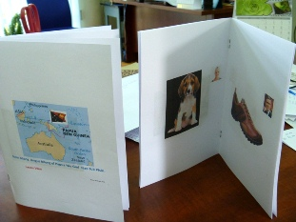
A multi-paged booklet can be printed from any PDF file with all the pages appearing in their intended sequence. A 12-page booklet, for instance, will be printed with pages 12 and 1 on the front of the first sheet, and 2 and 11 on its back. When folder together, the three sheets of paper will form a booklet with half-pages presented correctly from one to twelve from front to back.
Any Powerpoint slide-show can easily be saved as a PDF by clicking on “Save As” and choosing the “PDF” option from the drop-down list. This PDF can then be printed as a Booklet.
Note that individual slides can be “hidden” (right mouse click on a slide and choose “Hide Slide”) and therefore not appear in the PDF or the Booklet. That slide can then be Unhidden in the same way when required.
From a PDF file, select the Print option. In the resulting dialogue box locate the Page Scaling drop-down options box:
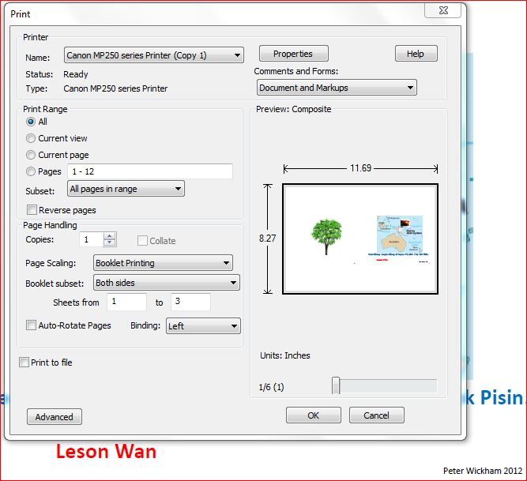
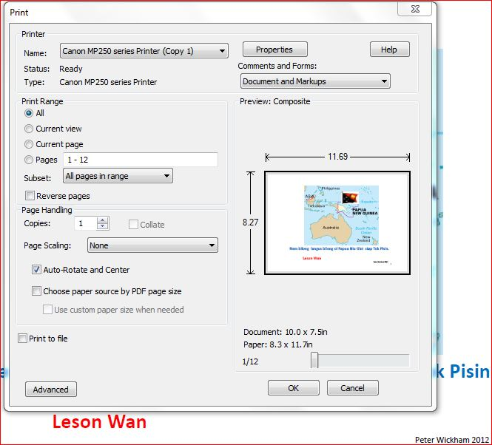

Click on this down-arrow to see options under Page Scaling. Click on “Booklet Printing” then “OK”.
Follow your printer’s instructions to remove your printed pages from the printer then re-insert them into the printer in-tray for double-sided printing.
Fold the completed pages together to form your half-A4 (now an A5) booklet.
Stapling the pages together on the fold is desirable but not essential. This is possible by using a long-reach stapler that is capable of this.

Effective uses of a Half-A4 Booklet

There are several situations in which an A5 booklet may be useful rather than a full A4 sheaf of papers:
- When it is desirable to display only one item in isolation per page to focus attention on that item. This smaller format of booklet lends itself more to this without wasting paper.
- Double-siding saves paper.
- The smaller A5 format is physically stronger than the larger A4 format. It can be held in one hand without flopping over.
- It is a book-like format that presents as a more authentic and familiar reading medium. The turning of pages and the two-page presentation can be useful in training young readers to read books.
- PowerPoint is a user-friendly program that readily allows pictures and text boxes to be inserted and manipulated on a page. This formatting transfers completely into PDF and is printed seamlessly.

