9/1/2012

|  |
| --- |
| By Peter Wickham English Language Training Fellow |



**Participant Notes**

**Developing an Effective Tool for Testing Speaking in Malaysian Schools**

Contents

Author 2

Introduction to This Workshop 4

*Activity One*  : How Valid and Authentic Is Your Test? 5

*Activity Two* : The Two Skills of Speaking and Listening 6

International English Language Testing System: An Overview 7

The IELTS Speaking Test Format 11

Section One 12

Section Two 12

Section Three 12

*Activity Three*  : Quick Quiz about the IELTS Speaking Test 13

13

Institutions in Malaysia That Accept IELTS 15

IELTS Speaking Band Descriptors 19

➢ Fluency and Coherence 19

➢ Lexical Resource 19

➢ Grammatical Range and Accuracy 19

➢ Pronunciation 19

*Activity Four* : Getting Familiar With IELTS Speaking Descriptors 21

*Activity Five* : Practice in Assessing IELTS Candidates 22

*Activity Six* : Constructing an Assessment Tool for Malaysian Students’ Speaking Assessment 27

Bibliography 28

# Author

Peter Wickham is a Brighton Education LS English Language Training Fellow at *Institut Pendidikan Kampus Dato’ Razali Ismail* in Kuala Terengganu, Malaysia, under a Ministry of Education project running from January 2011 to September 2013. He holds BEd (Edith Cowan University, Australia), MEd (TESOL)(distinction) from University of Wollongong, Australia 2010, Cert IV TESOL, Australia, and is an Australian registered teacher. He taught primary aged students in Australia for 20 years. He taught ESL to adults for 7 years in China, Turkey, UK, Saudi Arabia and Australia from 2004 to 2010 and coordinated a Preparation Year course at Dar Al Uloom University in Saudi Arabia. He was a field linguist in the Torres Strait from 1981 to 1989 with SIL International.

Contact at [esltrainer@gmail.com](mailto:esltrainer@gmail.com) or [peter.wickham@brightoneducationls.com](mailto:peter.wickham@brightoneducationls.com)

Download from <http://communicative.weebly.com>

Feedback is always useful. Please respond with the Contact Form on the website above.

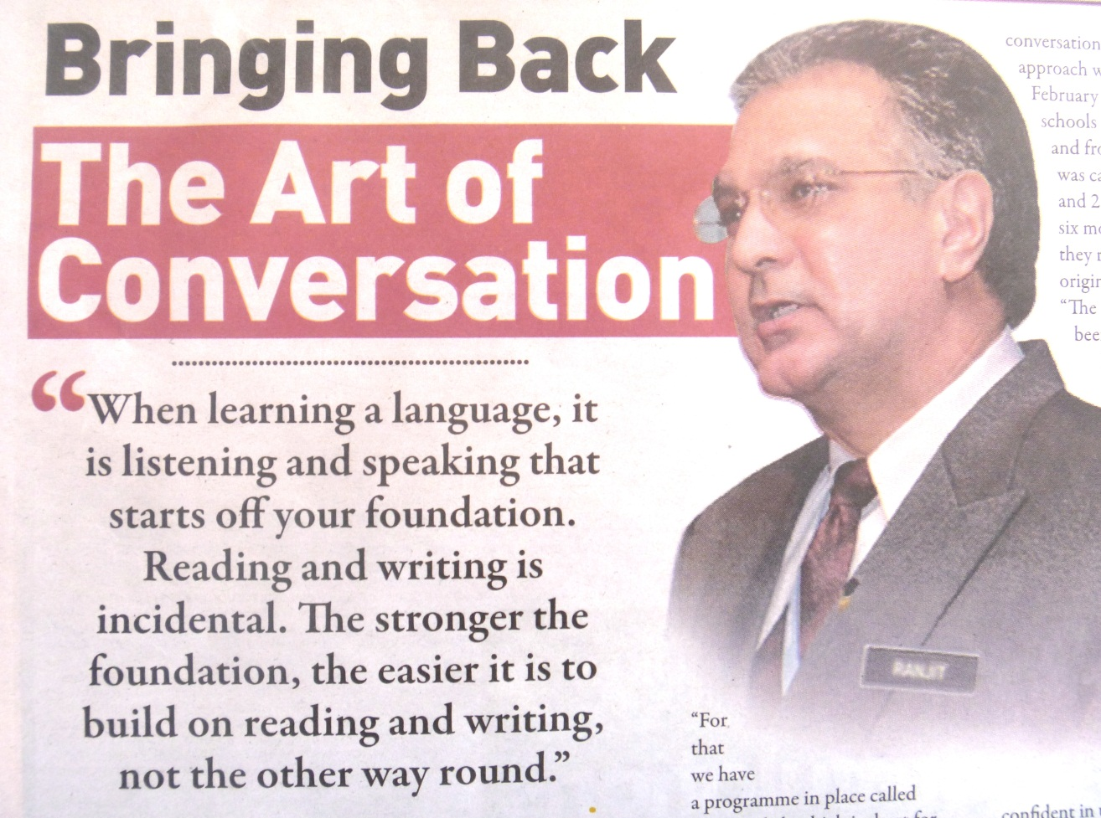General discussion: Do we agree with this statement?

Why or why not?

# Introduction to This Workshop

This workshop “Developing an Effective Tool for Assessing Speaking in Malaysian Schools” is designed to stimulate teachers and lecturers in Education to develop valid and authentic assessment tools for the Speaking component of Speaking and Listening.

The IELTS Speaking test is used here as a starting point in this quest. IELTS has been chosen for its proven **validity** and **authentic** methods, relying solely on oral presentation in a social context for assessing a candidate’s speaking proficiency. Most tools for assessing Speaking and Listening in schools are heavily weighted in favour of Listening, and even then rely heavily on Reading and Writing skills that can invalidate the test.

(See Brown (2004 p22-30) for discussions on Validity and Authenticity in assessment.)

Grolund (1998, p266) defines Validity as

***…the extent to which inferences made from assessment results are appropriate, meaningful, and useful in terms of the purpose of the assessment.***

Brown explains Authenticity as

***…when you make a claim for authenticity in a test task, you are saying that this task is likely to be re-enacted in the “real world”.***

By these definitions, the IELTS Speaking Test is both **valid** and **authentic**.

# *Activity One* : How Valid and Authentic Is Your Test?



1. Write a brief description of a test of a **student’s speaking ability** which you have seen or heard about in a Malaysian primary school.
2. By the definitions given on the previous page, assign a mark out of 10 for Validity and Authenticity to this test. Give reasons for your marking.

|  |  |
| --- | --- |
| **Speaking test**  **description** |  |
| **Validity** | **Mark /10**  **Reason:** |
| **Authenticity** | **Mark /10**  **Reason:** |

# *Activity Two* : The Two Skills of Speaking and Listening

The skills of Speaking and Listening are often clumped together as one skill area. Reading and Writing are usually separated into two distinct skill areas.

In your group of 3 or 4, list differences between Listening and Speaking. The first one is done for you as an example.

|  |  |  |
| --- | --- | --- |
|  | **Speaking** | **Listening** |
| **mode of communication** | output | input |
| **micro skills required** |  |  |
| **audience** |  |  |
| **affect** |  |  |
| **purpose** |  |  |
| **speed and timing** |  |  |
| **physical requirements** |  |  |
| **social skills** |  |  |
| **interactivity** |  |  |

# International English Language Testing System: An Overview

The present form of the IELTS test was developed by IDP Education Australia, Cambridge University and British Council following an evolution of admission tests of academic proficiency dating back to the 1950’s. (<http://www.ielts.org/about_us.aspx> )

This development of the IELTS test has led to utilization of four separate tests of English language proficiency – Reading, Writing, Listening and Speaking. Each has its own rationale and its own format.

The following excerpt gives an overview of the development of the modern IELTS test:

( <http://www.ielts.org/researchers/history_of_ielts.aspx> )

In 1987 British Council and UCLES EFL (now known as Cambridge ESOL) commissioned Edinburgh University to conduct a validation study (see Criper and Davies, 1988; Hughes, Porter and Weir, 1988). Following this report the ELTS Revision Project, under the academic direction of Professor Charles Alderson of Lancaster University, was set up to oversee the design and construction of the revised test (Alderson and Clapham, 1993).

There was consensus to broaden the international participation in the revision project and in response to this the International Development Program of Australian Universities and Colleges (IDP), now known as IDP Education Australia, joined British Council and UCLES to form an international partnership, reflected in the new name for the test: The International English Language Testing System (IELTS). The immediate outcome of this partnership was the secondment of an Australian academic, Professor David Ingram of Griffith University, to the revision project.

The recommendations of the revision team to simplify and shorten ELTS were accepted and a compromise was sought "between practicality and maximum predictive power". The number of subject-specific modules was reduced from six to three and the Non-Academic test was replaced by the General Module. IELTS first became operational in 1989 (Clapham and Alderson, 1997).

**Format of the 1989 IELTS**

From 1989 IELTS candidates took two non-specialised modules, Listening and Speaking, and two specialised modules, Reading and Writing. The non-specialised modules tested general English while the specialised modules were intended to test skills in particular areas suited to a candidate's chosen course of study. Specialised reading and writing modules (incorporating a direct link between the reading and writing activities) were available in three discipline fields which linked together related fields that had previously been separate modules in the ELTS battery, as shown below:

* Module A – Physical Science and Technology
* Module B – Life and Medical Sciences
* Module C – Business Studies and Social Sciences

|  |  |  |  |  |
| --- | --- | --- | --- | --- |
| Reading | Module A | Module B | Module C | General |
| Writing | Module A | Module B | Module C | General |
| Listening | Non-specialised Module | | | |
| Speaking | Non-specialised Module | | | |

Over the next five years the number of people taking the test rose by around 15% each year so that by 1995 there were over 43,000 candidates in 210 test centres around the world.

**1995 revision of IELTS**

In keeping with the commitment of the IELTS partners to respond to developments in applied linguistics, measurement theory and teaching practice, further modifications to the test were implemented in April 1995. In addition to a number of modifications to improve security and administration, there were three areas of significant change:

* The field-specific Reading and Writing Modules A, B and C were replaced with ONE Academic Reading Module and ONE Academic Writing Module. Details of the research behind this change to the test design can be found in Clapham (1996) who concluded that the different subject modules did not appear justified in terms of accessibility to specialists. In addition, the thematic link between the reading and writing activities was also removed to avoid confusing the assessment of reading ability with that of writing ability.
* General Training Reading and Writing Modules were brought into line with the Academic Reading and Writing Modules in terms of timing allocation, length of written responses and reporting of scores. The difference between the Academic and General Training Modules is in terms of the content, context and purpose for testing rather than the scales of ability.
* Measures were introduced to gather data on test performance and candidate background so that issues of fairness relating to test use and users could be more effectively monitored.

A brief summary of the 1995 revision of IELTS can be found in Charge and Taylor (1997).

**Continuing development**

In keeping with this history of innovation, the IELTS partners continue to be committed to the ongoing development of the test. A revision project for the Speaking Test was launched in 1998 and the revised IELTS Speaking Test was introduced in July 2001. New assessment criteria for the Writing Test were operational from January 2005. A computerised version

of IELTS was piloted in 2005 at a number of IELTS centres. Information on all these projects can be found in past issues of the IELTS Annual Review, and in Cambridge ESOL’s quarterly publication - Research Notes.

The current test retains many of the features of the 1980 ELTS including the emphasis on the comprehension of extended text in the receptive papers (Reading and Listening), and the direct testing of performance through a face-to-face Speaking test and the use of the essay and report formats in the Writing test. Other innovations such as the links of theme and content between papers and the experiment with subject specific modules have proved less successful and have not survived into the current incarnation. However, the distinction between academic and vocational purposes has stood the test of time and is still reflected in the choice of Academic and General Training modules. In recent years, the candidature has continued to grow rapidly, with over 1.5 million tests taken in 2011.

A full account of the development ELTS/IELTS and its place in the history of testing English for academic purposes can be found in Davies (2008).

# The IELTS Speaking Test Format

**( <http://australianetwork.com/passport/> )**

***About the IELTS Speaking Test***

*The 3 parts are constructed to cover a range of language features - verb tenses (present, past and future, active/passive); functions (explaining, describing, suggesting, predicting, narrating, comparing); and grammatical structures (cause/effect, reason, conditionals and comparatives). The candidate is expected to demonstrate a range of sentence types (simple, compound and complex) as well as a logical and well-constructed response. Pronunciation and fluency are also assessed.   
  
A range of topics is covered, from common everyday topics such as the family, lifestyle, transport, diet, travel, and sports to more challenging topics such as technology, society, education, employment, health, and some of the sciences to include topics such as the weather, climate change, pollution, global warming and the environment.  
  
For more information on IELTS:*[*http://www.ielts.org*](http://www.ielts.org) *For more information on Speaking Criteria (Public Version):*[*http://www.ielts.org/PDF/UOBDs_SpeakingFinal.pdf*](http://www.ielts.org/PDF/UOBDs_SpeakingFinal.pdf) *[pdf]*

The Speaking Test ( <http://www.ielts.school.nz/ieltstestspeak.htm> )

The Three Sections

## Section One

The candidate is interviewed by the examiner and will be required to answer general questions related to themselves, family, job, studies or other familiar topic areas and this lasts for approximately 4 – 5 minutes.

## Section Two

The candidate is given a card which has a topic selected by the examiner (this cannot be changed), the candidate is given one minute to prepare some notes and then has to talk continuously for between one and two minutes on the given topic.  The examiner will then ask a couple of question to follow up in a more abstract manner on the same topic.  This section lasts between 3 – 4 minutes including preparation time.

## Section Three

The examiner and candidate will continue the conversation based more loosely around the topic area from section 2, for a further 4 – 5 minutes.  The examiner will close the interview.

Skill Types in Part Three:

* Description
* Explanation
* Comparison
* Evaluation
* Speculation
* Justification
* Summarisation
* Expansion

The interview lasts between 11 – 14 minutes.

# 

# *Activity Three* : Quick Quiz about the IELTS Speaking Test

# 

1. Which three institutions jointly own and run IELTS?
2. In which year did IELTS first become operational?
3. How many IELTS tests were undertaken in 2011?
4. How many minutes does the Speaking test interview run for?
5. Describe the three sections of the IELTS Speaking test:

Section 1:

Section 2:

Section 3:

1. How many scoring bands are there in the IELTS Speaking test? (Hint: See the next page.)
2. Write the URL for a website where you can find information about the IELTS Speaking test.

***When everyone in your group has finished, share your answers with the group.***

**Scoring and Bands** ( <http://www.ielts.school.nz/ieltstestscore.htm> )

There is no such thing as a pass or fail in IELTS as it is just an indicator of the level achieved in the test on that day.  Candidates may require a specific level for entry into University or for immigration purposes and this level will be preset by the appropriate institution.  The level indicators or bands used in IELTS are as follows:

|  |  |  |
| --- | --- | --- |
| IELTS Bands | | |
| Band | Definition |  |
| 9 | Expert user | Full operational command and completely fluent. |
| 8 | Very good user | Handles complex language well with just the occasional inaccuracy.  May misunderstand unfamiliar situations.  Good with detailed argumentation. |
| 7 | Good user | Good command of English with occasional inaccuracies and inconsistencies.  Can handle complex language and situations including detailed reasoning. |
| 6 | Competent user | Has a good command of English despite numerous errors and can use quite difficult language especially in familiar situations. |
| 5 | Modest user | Can handle basic communication although is likely to make numerous mistakes.  Can handle situations quite well in familiar circumstances |
| 4 | Limited user | Competence in familiar situations only. Does not understand complex language. |
| 3 | Extremely limited user | Can only use English in very familiar circumstances.  Frequently stops and cannot continue |
| 2 | Intermittent user | Has great difficulty with all aspects of English and cannot communicate other than with isolated words. Not familiar with written and spoken English. |
| 1 | Non user | No ability maybe a few isolated words |
| 0 | Did not attempt the test | No recognizable information |

Institutions in Malaysia That Accept IELTS (<http://bandscore.ielts.org>)

As can be seen below, IELTS test scores are accepted in a wide range of institutions within Malaysia.

|  |  |
| --- | --- |
| Alborz Technical & Vocational | New Zealand High Commission |
| Australian Dept Foreign Affairs - Malaysia | Nilai College |
| Australian Dept Immigration &Citizenship - KL | Olympia College Malaysia |
| Australian High Commission - Malaysia | Public Services Department |
| British High Commission - Kuala Lumpur | Shell Malaysia |
| CPA Malaysia | Stamford College - Malaysia |
| Curtin University of Technology, Sarawak | Swinburne University of Technology - Sarawak |
| High Commission of Canada, Malaysia | Swinburne University of Technology, Malaysia |
| IDP Education Australia - Johur Bahru | Taylor's College |
| IDP Education Australia - Kuala Lumpur | Taylor's University |
| IDP Malaysia | The National University of Malaysia (UKM) |
| Institut des Hautes Etudes en Management | TOC The Otomotif College |
| Institute Kejo Tekni Tenaga Nasionl | UCSI University |
| International Islamic University Malaysia (IIUM) | Universiti Institute Teknologi Mara |
| International Medical University (IMU) | Universiti Malaysia |
| International School of Kuala Lumpur | Universiti Putra Malaysia |
| Inti University College | Universiti Sains Malaysia |
| Kolej Poly-Tech MARA | Universiti Teknologi Malaysia |
| Legenda Education Group | Universiti Tenaga Nasional |
| Mahkota College | Universiti Utara Malaysia |
| Malaysian Rubber Board | University of Malaya |
| MARA Headquarters | University of Nottingham Malaysia Campus |
| Ministry of Health | University Tun Abdul Razak (UNITAR) |
| Ministry of Science, Technology and Environment | Upper Iowa University - Malaysia |
| Monash University, Sunway Campus | Westminster International College |
| Mont Kiara International School | New Zealand High Commission, Malaysia |

IELTS scores are accepted by thousands of higher education institution throughout the Western world. Their details are too many to list here. Go to <http://bandscore.ielts.org> to access the comprehensive list.

**Samples of Acceptable IELTS Scores for Admission to Courses**

The Four IELTS tests are scored from nine bandscores, 9 being “Native English Speaker” level, and 1 being “not Assessable”. A candidate should generally attain an IELTS 5.0 to 5.5 for entry into a university foundation course, and around 6.0 to 7.0 to be admitted into a degree course, depending on the particular university and the particular faculty.

The following tables give typical examples of acceptable IELTS levels for admission to higher education.

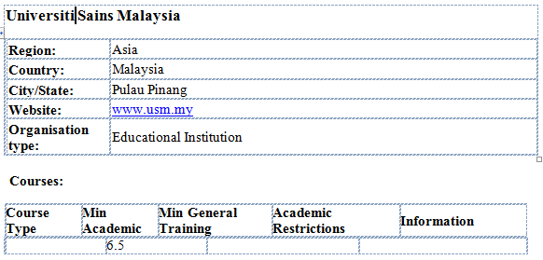

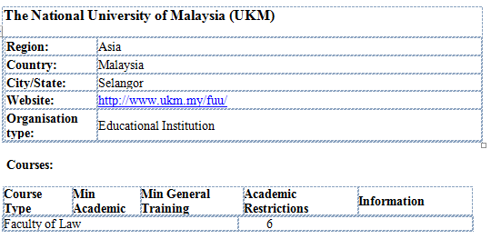

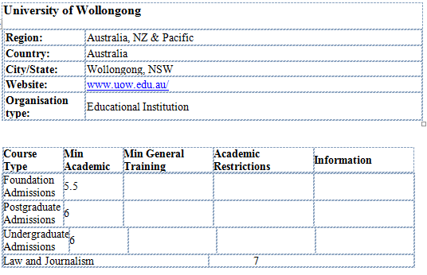

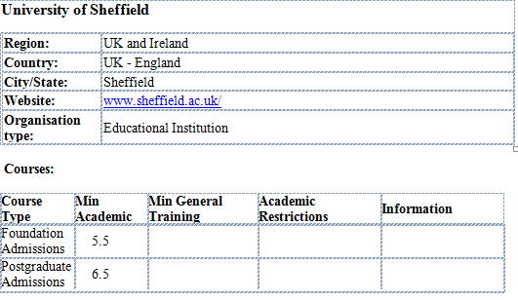

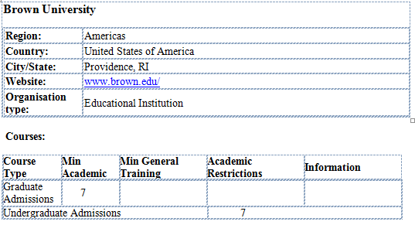

# IELTS Speaking Band Descriptors

The IELTS Speaking Test is based on four sets of descriptors under the headings of:

## Fluency and Coherence

The degree to which the candidate keeps conversation flowing at a pace suitable to the conversation, and using speech patterns that show comfortable dynamic use of English language.

## Lexical Resource

The degree to which the candidate uses paraphrasing with a wide variety of words and phrases.

## Grammatical Range and Accuracy

The degree to which the candidate structures their speech using appropriate blends of simple and complex sentences.

## Pronunciation

The degree to which the candidate pronounces the sounds of the English language without ambiguity.

The full chart of IELTS Speaking Descriptors appears on the next page. You will also be given a copy to use in Activity Four.

**IELTS Speaking Descriptors**

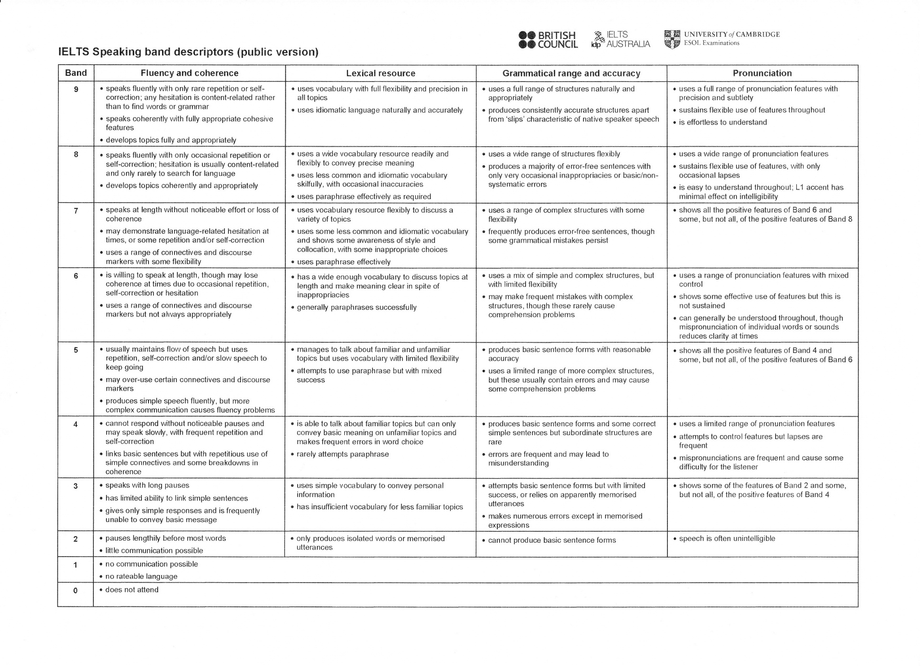

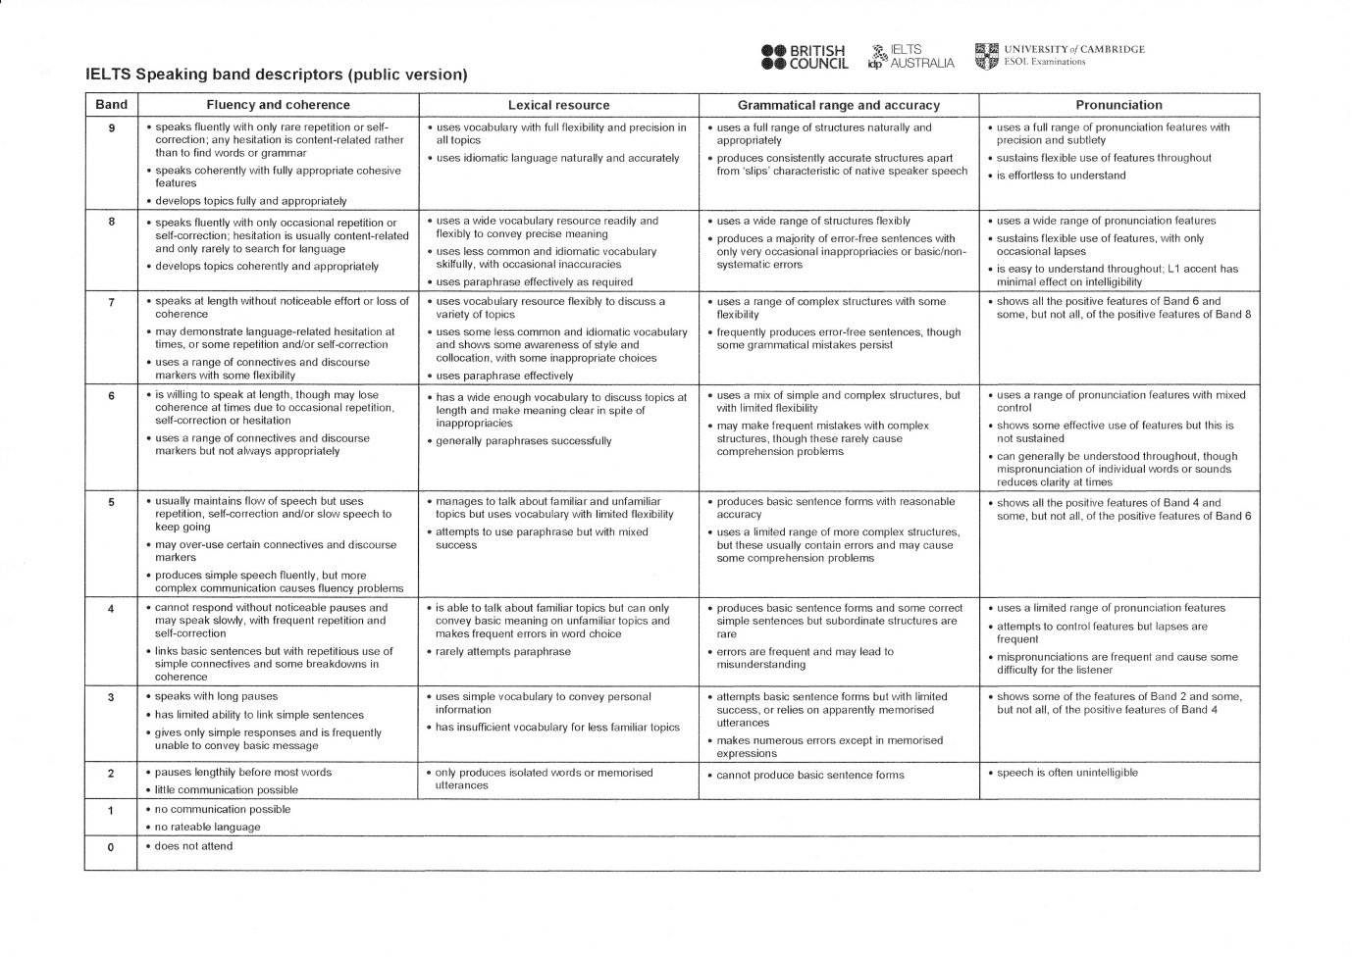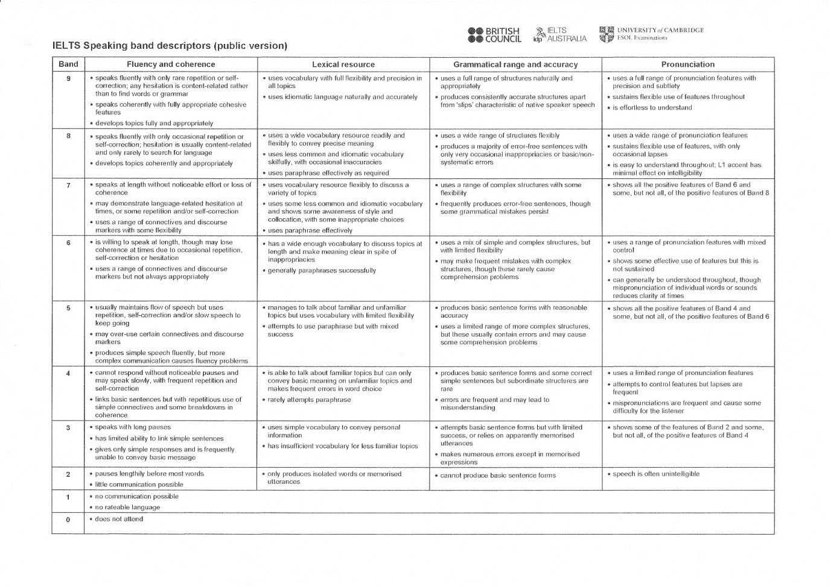

# *Activity Four* : Getting Familiar With IELTS Speaking Descriptors



(10 minutes)

* **In a group of four, Taken turns to read aloud the descriptors from one of the four columns. Begin with band 9 at the top and progress down to band 1.**
* **Comment on the difference between each band and the previous band.**
* **Note the similarities and the difference.**
* **Make note of questions you have about the meaning of the descriptors.**
* **Be prepared to discuss your questions and comments with the whole workshop.**

# *Activity Five* : Practice in Assessing IELTS Candidates

Now let us take the role of IELTS examiners, and listen to several candidates for the IELTS Speaking test.

Take note of the candidate’s proficiency in each of the four areas of proficiency, assigning them a **whole-number** score in each of the four columns. These scores must be expressed in whole numbers from 0 to 9.

When this stage is complete, add the four figures and divide by four. Round the score DOWN to the nearest 0.5.

For example, Candidate A’s IELTS Speaking scores of 7, 6, 4 and 4 add to a total of 21.

21 divided by 4 equals 5.25. Candidates A’s IELTS Speaking score is 5.0.

Candidate B’s A’s IELTS Speaking scores of 7, 7, 6 and 7 add to a total of 27.

27 divided by 4 equals 6.75. Candidate B’s IELTS Speaking score is 6.5.

Use the marking grid on the following page to score each candidate as you listen to a section of their IELTS Speaking test.

|  |  |  |  |  |
| --- | --- | --- | --- | --- |
| Candidate: | | | | |
|  | *Fluency & Coherence* | *Lexical Resource* | *Grammatical Range & Accuracy* | *Pronunciation* |
| Scores in whole numbers: |  |  |  |  |
| Scores Total: | | | Score Average: | |
| Score Average rounded DOWN to nearest 0.5: | | | | |

|  |  |  |  |  |
| --- | --- | --- | --- | --- |
| Candidate: | | | | |
|  | *Fluency & Coherence* | *Lexical Resource* | *Grammatical Range & Accuracy* | *Pronunciation* |
| Scores in whole numbers: |  |  |  |  |
| Scores Total: | | | Score Average: | |
| Score Average rounded DOWN to nearest 0.5: | | | | |

|  |  |  |  |  |
| --- | --- | --- | --- | --- |
| Candidate: | | | | |
|  | *Fluency & Coherence* | *Lexical Resource* | *Grammatical Range & Accuracy* | *Pronunciation* |
| Scores in whole numbers: |  |  |  |  |
| Scores Total: | | | Score Average: | |
| Score Average rounded DOWN to nearest 0.5: | | | | |

|  |  |  |  |  |
| --- | --- | --- | --- | --- |
| Candidate: | | | | |
|  | *Fluency & Coherence* | *Lexical Resource* | *Grammatical Range & Accuracy* | *Pronunciation* |
| Scores in whole numbers: |  |  |  |  |
| Scores Total: | | | Score Average: | |
| Score Average rounded DOWN to nearest 0.5: | | | | |

|  |  |  |  |  |
| --- | --- | --- | --- | --- |
| Candidate: | | | | |
|  | *Fluency & Coherence* | *Lexical Resource* | *Grammatical Range & Accuracy* | *Pronunciation* |
| Scores in whole numbers: |  |  |  |  |
| Scores Total: | | | Score Average: | |
| Score Average rounded DOWN to nearest 0.5: | | | | |

|  |  |  |  |  |
| --- | --- | --- | --- | --- |
| Candidate: | | | | |
|  | *Fluency & Coherence* | *Lexical Resource* | *Grammatical Range & Accuracy* | *Pronunciation* |
| Scores in whole numbers: |  |  |  |  |
| Scores Total: | | | Score Average: | |
| Score Average rounded DOWN to nearest 0.5: | | | | |

|  |  |  |  |  |
| --- | --- | --- | --- | --- |
| Candidate: | | | | |
|  | *Fluency & Coherence* | *Lexical Resource* | *Grammatical Range & Accuracy* | *Pronunciation* |
| Scores in whole numbers: |  |  |  |  |
| Scores Total: | | | Score Average: | |
| Score Average rounded DOWN to nearest 0.5: | | | | |

|  |  |  |  |  |
| --- | --- | --- | --- | --- |
| Candidate: | | | | |
|  | *Fluency & Coherence* | *Lexical Resource* | *Grammatical Range & Accuracy* | *Pronunciation* |
| Scores in whole numbers: |  |  |  |  |
| Scores Total: | | | Score Average: | |
| Score Average rounded DOWN to nearest 0.5: | | | | |

|  |  |  |  |  |
| --- | --- | --- | --- | --- |
| Candidate: | | | | |
|  | *Fluency & Coherence* | *Lexical Resource* | *Grammatical Range & Accuracy* | *Pronunciation* |
| Scores in whole numbers: |  |  |  |  |
| Scores Total: | | | Score Average: | |
| Score Average rounded DOWN to nearest 0.5: | | | | |

|  |  |  |  |  |
| --- | --- | --- | --- | --- |
| Candidate: | | | | |
|  | *Fluency & Coherence* | *Lexical Resource* | *Grammatical Range & Accuracy* | *Pronunciation* |
| Scores in whole numbers: |  |  |  |  |
| Scores Total: | | | Score Average: | |
| Score Average rounded DOWN to nearest 0.5: | | | | |

|  |  |  |  |  |
| --- | --- | --- | --- | --- |
| Candidate: | | | | |
|  | *Fluency & Coherence* | *Lexical Resource* | *Grammatical Range & Accuracy* | *Pronunciation* |
| Scores in whole numbers: |  |  |  |  |
| Scores Total: | | | Score Average: | |
| Score Average rounded DOWN to nearest 0.5: | | | | |

|  |  |  |  |  |
| --- | --- | --- | --- | --- |
| Candidate: | | | | |
|  | *Fluency & Coherence* | *Lexical Resource* | *Grammatical Range & Accuracy* | *Pronunciation* |
| Scores in whole numbers: |  |  |  |  |
| Scores Total: | | | Score Average: | |
| Score Average rounded DOWN to nearest 0.5: | | | | |

# *Activity Six* : Constructing an Assessment Tool for Malaysian Students’ Speaking Assessment

 In your group of 3-4 people, discuss the features of English speech of Malaysian primary school students, and how these features can be incorporated into a speech assessment tool similar in nature to the IELTS Speaking test.

Draw up a list of speech patterns to be observed and assessed by Malaysian teachers. Take clues from the KSSR, your experience of teaching, and your knowledge of the English language.

|  |  |
| --- | --- |
| **Fluency and Coherence** | **Lexical Resource** |
| **Grammatical Range and Accuracy** | **Pronunciation** |

# Bibliography

(2012, September). Retrieved from Australia Network: http://australianetwork.com/passport/

(2012, September). Retrieved from IELTS for Teachers Students: http://www.ielts.school.nz/ieltstestspeak.htm

Alderson, J., & Clapham, C. (1993). *Examining the ELTS Test: An Account of the First Stage of the ELTS Revision Project - Research Report.* The British Council/University of Cambridge Local Examinations Syndicate.

British Council. (n.d.). Retrieved from IELTS: ielts@britishcouncil.org

Brown, H. D. (2004). *Language Assessment: Principles and classroom practices.* White Plains, New York: Longman.

Charge, N., & Taylor, L. (1988). Recent Developments in IELTS. *English Language Teaching Journal*.

Clapham, C. (1996). *Constructing and trialling the IELTS Test - Research Report 3.*

Clapham, C. (1996). The development of IELTS: a study of the effect of background knowledge on reading comprehension. *Studies in language Testing vol4*.

Criper, C., & Davies, A. (1998). *ELTS Validation Project Report: Research Report 1(i).* The British Council/University of Cambridge Local Examinations Syndicate.

Davies, A. (2008). *Assessing Academic English: Testing English Proficiency, 1950 - 1989 - the IELTS solution.* Cambridge: CUP.

Gronlund, N. (1998). *Assessment of Student Achievement.* Boston: Allyn and Bacon.

Hughes, A., Porter, D., & Weir, C. (1988). *ELTS Validation Project report: Proceedings of a conference held to consider the ELTS Validation Project Report 1(iii).* The British Copuncil/ University of Cambridge Local Examinations Syndicate.

IELTS. (2012, September). *About IELTS*. Retrieved from IELTS: http://www.ielts.org/about_us.aspx

IELTS. (2012, September). *History of IELTS*. Retrieved from IELTS: http://www.ielts.org/researchers/history_of_ielts.aspx

Wickham, P. (2012, September). *Developing an Effective Tool for Testing Speaking in Malaysian Schools*. Retrieved from Communicative ESL: http://communicative.weebly.com/